

SCHOOL OF Business
ASSIGNMENT COVER SHEET

STUDENT DETAILS
Student name: |  |  |  | Namesh Panneer Selvan |  |  |  |  |  | Student ID number: |  |  |  | 22167569
UNIT AND TUTORIAL DETAILS
Unit name: |  |  | Business Analytics in Practice |  |  |  |  |  |  |  |  | Unit number: |  |  | BUSM7105
Tutorial/Lecture: |  |  |  |  | Group 3 |  |  |  |  |  | Class day and time: |  |  |  |  | Tuesday , 6:00 – 9:00
Lecturer or Tutor name: |  |  |  |  |  |  | Dr.Jiahe Chen
ASSIGNMENT DETAILS
Title: |  | Data Driven Framework to Reduce Road Accident
Length: |  | 1500 words |  |  |  |  | Due date: | 15 Aug. 25 |  |  |  |  | Date submitted: |  |  |  | 15 Aug. 25
Home campus (where you are enrolled): |  |  |  |  |  |  |  |  | Parramatta City
DECLARATION
 | I hold a copy of this assignment if the original is lost or damaged.
 | I hereby certify that no part of this assignment or product has been copied from any other student’s work or from any other source except where due acknowledgement is made in the assignment.
 | I hereby certify that no part of this assignment or product has been submitted by me in another (previous or current) assessment, except where appropriately referenced, and with prior permission from the Lecturer / Tutor / Unit Coordinator for this unit.
 | No part of the assignment/product has been written/produced for me by any other person except where collaboration has been authorised by the Lecturer / Tutor /Unit Coordinator concerned.
 | I am aware that this work will be reproduced and submitted to plagiarism detection software programs for the purpose of detecting possible plagiarism (which may retain a copy on its database for future plagiarism checking).
Student’s signature: |  |  |  |  |  | Janvi Malhotra
Note: An examiner or lecturer / tutor has the right to not mark this assignment if the above declaration has not been signed.

Table of Contents

- Project Description………………………………………… 4
- Project Scope………………………………………………. 4
- Business Case……………………………………………….5
- Research Question…………………………………………..5
- Stakeholder Analysis………………………………………..6
- Constraints…………………………………………………. 6
- Project Deliverables…………………………………………6
- Data Description…………………………………………….7
- Visual Analytics (Tableau)…………………………………..9
- Decision Making and Recommendation…………………….10
- Conclusion…………………………………………………..11
- References…………………………………………………..11

BUSM7105
Project Name:
Data-Driven Framework to Reduce Road Accidents

Project Manager: Dr. Jiahe Chen
Project Approval Date: 30 July 2025
Last Revision Date:14 August 2025

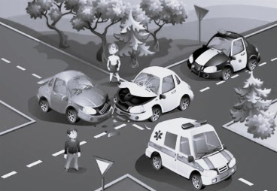
- Project Description:
Road traffic accidents in the United Kingdom still pose significant challenges to society in the form of loss of life and in economic terms. To overcome these concerns, there is a need to transcend the normal modes of analysis that usually provide superficial information on the identities of specific risks. The approach taken by this project is data-oriented, and the analysis of large-scale databases on accidents provides evidence of correlations to location, weather, type of roadway, and amount of traffic. Enhanced accuracy is achieved through supplementary sources such as OpenStreetMap (OSM) and Visual Crossing to provide spatial and environmental data. The ensuing insights are expected to assist the policymakers in locating risky areas, creating specific safety measures, shortening response times of registration, and, eventually, decreasing the severity of accidents and rate of casualties on a national level.
The report majorly focuses on the utilization of modern methods of data analytics by creating data-driven dashboards that represent a clear understanding of historical trends and help in identifying accidental hotspots for not only conducting better and faster rescue operations but also having an overall understanding of the factors affecting these road accidents and creating better infrastructure development around it (Choudhary, Rayala, Kiasari & Jafari 2023).
- Project Scope:
- Data collection and preparation -
Use of historical datasets like vehicle type, location, weather conditions, etc.
- Descriptive analysis -
Finding hotspots and risk factors through data visualization.
For example: correlation between different variables (ex, vehicle type and severity of accident)
- Provide recommendations: -
Identify data-driven safety measures and make recommendations and strategies for high-risk zones and conditions.
- Stakeholder engagement: -
Putting insightful visualization frameworks for urban planners to make appropriate decisions for public safety.
- Improvement and evaluation: -
Evaluate the effectiveness of the model in terms of accuracy, recall, and precision, while continuing to refine it with updated data to maintain its ongoing relevance.
- Business Case:
The UK experiences a significant impact on its public health and economic cost due to road traffic accidents. By implementing a targeted data-driven framework around datasets like vehicle type, time & date, type of road and situation, and driver's age, combined with machine learning tools, interactive visual dashboards, and strategic initiatives, we can enable the creation of a structured emergency response plan with appropriate policies and procedures. This can help in reducing the number of road accidents and creating a better road infrastructure (Sohail et al. 2022).

Key benefits of using a data-driven framework:
A targeted approach towards speed management and proper road traffic signs, specifically in accident hotspots, can reduce the rate of accidents by 15% (Kazmi et al. 2022).
Improving the emergency response plan by categorizing the severity level of incidents and creating an incident management plan around the same. Using machine learning tools for creating a time series of accidents for forecasting accident trends (Sufian & Varadarajan, 2023).
Creating a descriptive and interactive dashboard including maps and policies for each situation, based on which appropriate decisions can be taken around road safety. This dashboard can help in understanding the historical patterns and risky roads, based on which predictive analysis can be done (Sakib et al. 2018).
- Research Question:

- What are the patterns and correlations between factors like time, location, weather, type of vehicle, and severity of accidents?

- How does the use of a combination of machine learning and time series forecasting improve the early identification of risky times for UK road traffic accidents?

- Stakeholder Analysis:
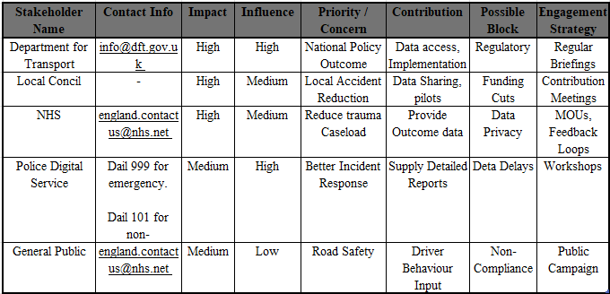
- Constraints:
- Time: The Time constraint of project completion by 15 August 2025 cannot allow much model development or prospective designs.
- Quality - Data that oneself will rely on the fullness and correctness of the accidental data; inaccurate data in the weather and type of road can affect results.
- Scope -The four variables (weather, time, location, vehicle type) can only be correlated with the severity of the accidents.
- Budget- Limited access to high-quality geospatial data and more sophisticated statistical programs than Tableau and open-source tools.
- Risk: The possibility of a non-technical stakeholder confusing either of the two correlations with causation.

- Project Deliverables:
In this project, the UK accident data will be investigated to reveal information that can help direct focused efforts and improve road safety (Kazmi, 2022). The deliverables are:
- Data sanitization of databases containing accident records.
- Descriptive dashboard and data visualizations.
- Mapping of accident reports based on geographical IT systems.
- Analyzing weather, road traffic, and accident time for understanding a pattern.
- Correlating risk elements based on data analysis.
- Accident severity can be predicted using data modelling.
- Deviations & trends can be identified using Exploratory data analysis (EDA).

- Data Description:
The dataset underpinning this analysis comprises 660,679 road traffic accident records in the United Kingdom from 2019 to 2022, sourced from the Department of Transport’s official police-recorded statistics (STATS19). Records like accident severity, district area, accident date, weather conditions, light conditions, road type, road surface conditions, vehicle type, number of casualties, and geospatial coordinates. These fields enable a multifaceted exploration of the factors influencing accident occurrence and severity.
- Accidents due to weather conditions:
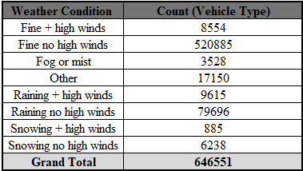
The above table shows the largest incident volumes under clear weather without high winds (“Fine, no high winds”) with 520,885 cases and heavy rain without high winds (“Raining, no high winds”) with 79,696 cases. Conditions like “Fog or mist” (3,528 cases) and “Snowing with high winds” (885 cases) are significantly lower.
The chart below indicates that bad weather contributes to a reduced number of accidents, which tend to be more severe, whereas a massive proportion of accidents during good weather is more than probable.
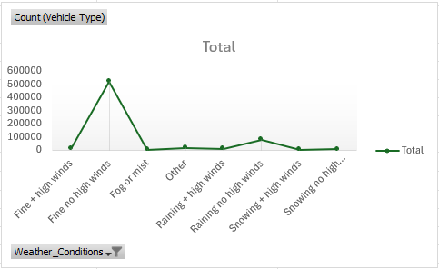
Data quality should be considered before getting into deeper analysis. The assessment showed some missing values under certain fields like road type, weather conditions, and geospatial coordinates, limiting spatial or other general data points. However, through data processing & sanitisation methods, a robust foundation can be created which will be used further in statistical and geospatial modelling.
- Accident Severity based on Vehicle Type:
The data shows critical trends in which types of vehicles and degrees of accidents occur, as portrayed below.
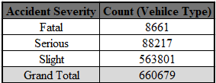
The degrees of accident severity are classified as Fatal (~1%, 8,661 cases), Serious (~14%, 88,217 cases), and Slight (~85%, 563,801 cases). Vehicles will include cars, motorcycles (by engine size), buses, minibuses, goods vehicles, taxis, pedal cycles, and agricultural vehicles. Cars represent about two-thirds of the number of incidents, their popularity as well as relative risk, as compared to the other vehicle types. The percentages of motorcycles differ, with the first being the engine size, and bicycles and buses are smaller, but still a point in the risk analysis. Minor accidents happen more frequently than Fatal or Serious ones.
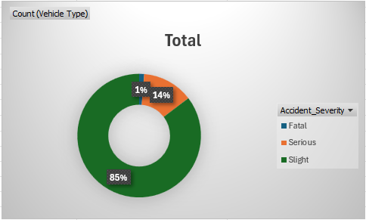
All of these analyses together indicate that the detail in the dataset can be used to inform specific policy implementation, resource investment, and active management of risky vehicle categories. Its extensive nature and its varying scope give it a solid supporting empirical foundation for evidence-based enhancements of UK road safety.

- Visual Analytics (Tableau):
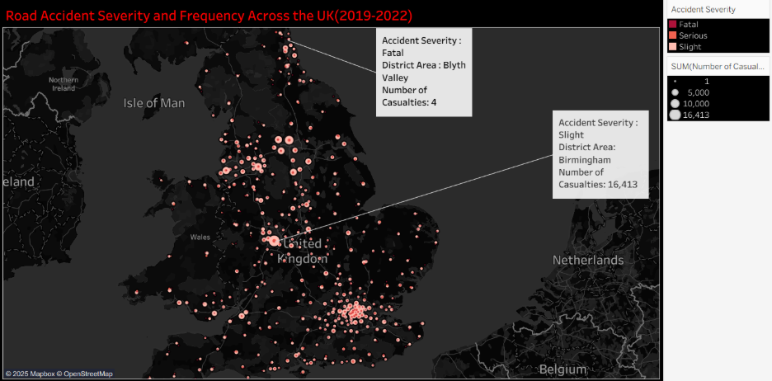
The visualization identifies the location of road accidents by severity and frequency across the UK and therefore indicates the spatial distribution of accidents by district. Each of the circles depicts a place where the accidents happen, and the size of the circle is proportional to the quantity of casualties and the color starts with fatal (light pink), serious (red), and slight (dark red) accidents. The black background also increases the visual contrast, and thus it makes the high racial concentration of accidents better seen.
The visualisation indicates increased accident casualties in the main cities, such as Birmingham, with larger circles, and as it expands further to the countryside, the circles are smaller, indicating that fewer accidents occur in this region. The use of location and severity data has allowed the map to reveal areas of high risk, which can facilitate policies to set road safety initiatives and direct resources where they are most important.
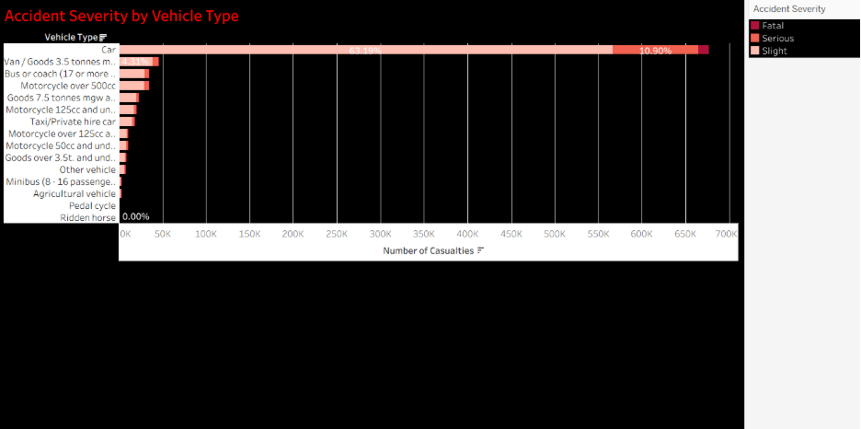
The visualization demonstrates how severe various types of accidents were based on the vehicle types in the UK that took place between 2019 and 2022. Casualties are mainly due to cars and then vans, and motorbikes. The ratio of fatal accidents is higher in the case of motorbikes than in any other vehicle type; however, minor injuries are more prevalent in all types of vehicles, which emphasizes the necessity to find road safety solutions that are biased towards vulnerable groups of vehicles.
- Decision making and recommendations:
Based on the above analysis, most of the accidents happened during good weather conditions, where the majority of cars and motorcycles have reported the highest risk injury (Choudhary et al, 2023). Urban areas like Birmingham have made significant efforts in identifying hot spots, better traffic controls, and improvements towards road infrastructure (Kazmi et al, 2022).

The analysis came up with various potential interventions:
- Install a speed-adjusting system in clear weather conditions to check excessive speeding, which is due to overconfidence.
- Deploy localized campaigns of enforcement and awareness in your geographic hotspots.
- Implement measures to increase safety, including staggered work schedules, during commuter times to cut down on rush-hour traffic.
- Improve the infrastructure of vulnerable road users, especially in the areas of accident hotspots.
As a result of the stakeholder consultation, Option 1 and Option 4 can be chosen as the priorities since they can decrease some severe accidents without seriously impacting the traffic. Such solutions are correlated with the Safe System the World Health Organization (WHO, 2017) recommends.
- Conclusion:
The visualisation helps to verify that the highest frequency of accidents is recorded when the weather is clear and at the busiest commuting time, and the largest number of accidents happen in urban settings, and rural roads are more severe. Incidents are dominated by cars; nevertheless, motorcyclists and cyclists are subjected to even graver results. This knowledge helps to develop dedicated, data-informed solutions to mitigate safety risks to high-risk regions and undesirable users.
- References:
Choudhary, JK, Rayala, N, Kiasari, AE & Jafari, F 2023, ‘Road safety in Great Britain: An exploratory data analysis’, UEL Research Repository, 13 August, viewed 13 August 2025, https://repository.uel.ac.uk/item/8wz6y.
Kazmi, SSA, Ahmed, M, Mumtaz, R & Anwar, Z 2022, ‘Spatiotemporal clustering and analysis of road accident hotspots by exploiting GIS technology and kernel density estimation’, The Computer Journal, 11 August, viewed 11 August 2025, https://doi.org/10.1093/comjnl/bxz158.
Sakib, A, Ismail, SA, Sarkan, H, Azmi, A & Yusop, OM 2018, ‘Analysing traffic accident and casualty trend using data visualization’, SpringerLink, 11 August, viewed 11 August 2025, https://doi.org/10.1007/978-3-319-99007-1_9.
Sohail, A, Cheema, MA, Ali, ME & Toosi, AN 2022, ‘Data-driven approaches for road safety: a comprehensive systematic literature review’, Monash University, 11 August, viewed 11 August 2025, https://adelnadjarantoosi.info/pdf/SS2022.pdf.
Sufian, MA & Varadarajan, J 2023, ‘Enhancing prediction and analysis of UK road traffic accident severity using AI: Integration of machine learning, econometric techniques, and time series forecasting in public health research’, arXiv, 11 August, viewed 11 August 2025, https://arxiv.org/abs/2309.13483.
World Health Organization 2017, Save LIVES: A road safety technical package, WHO Press, Geneva.
- Appendices
Appendix A – Dataset Snapshot
The dataset used in this project comprises 660,679 accident records (2019–2022) from the UK Department of Transport’s STATS19 police-reported statistics. Below is a sample extract showing key variables:
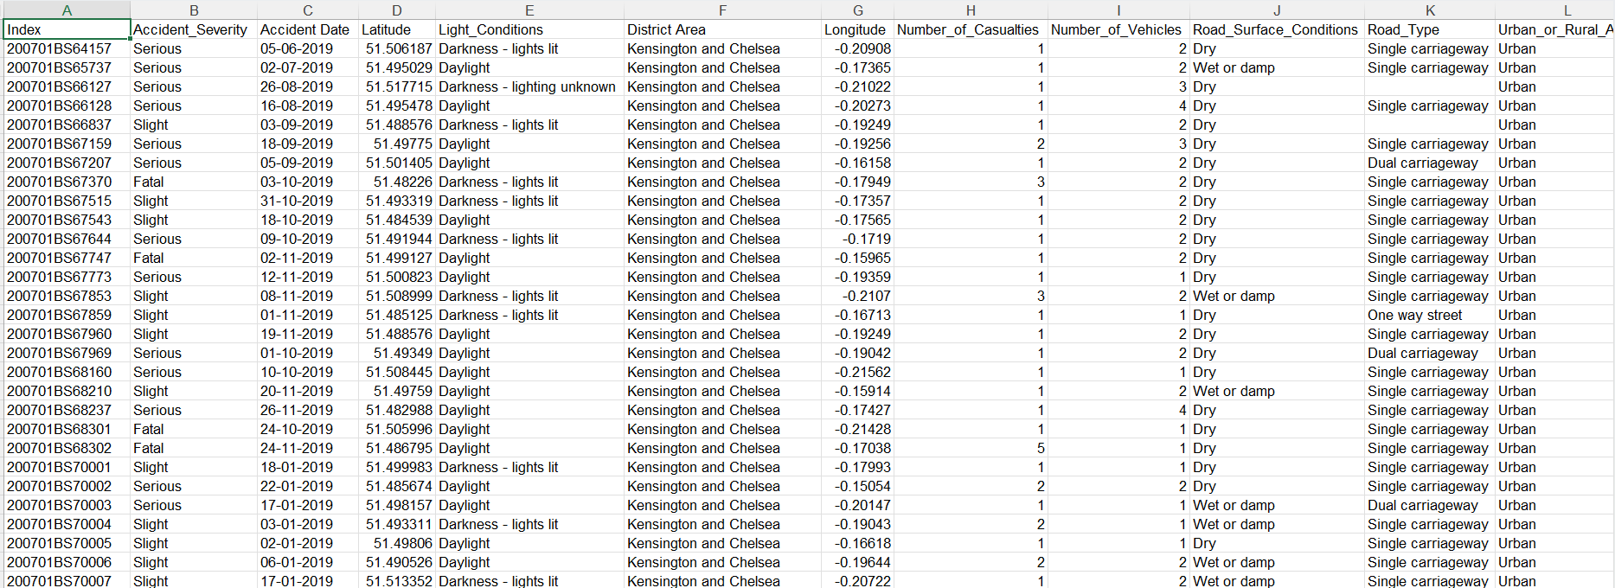

Appendix B – Visualisation Screenshots
B1. Accident Hotspot Map by Location
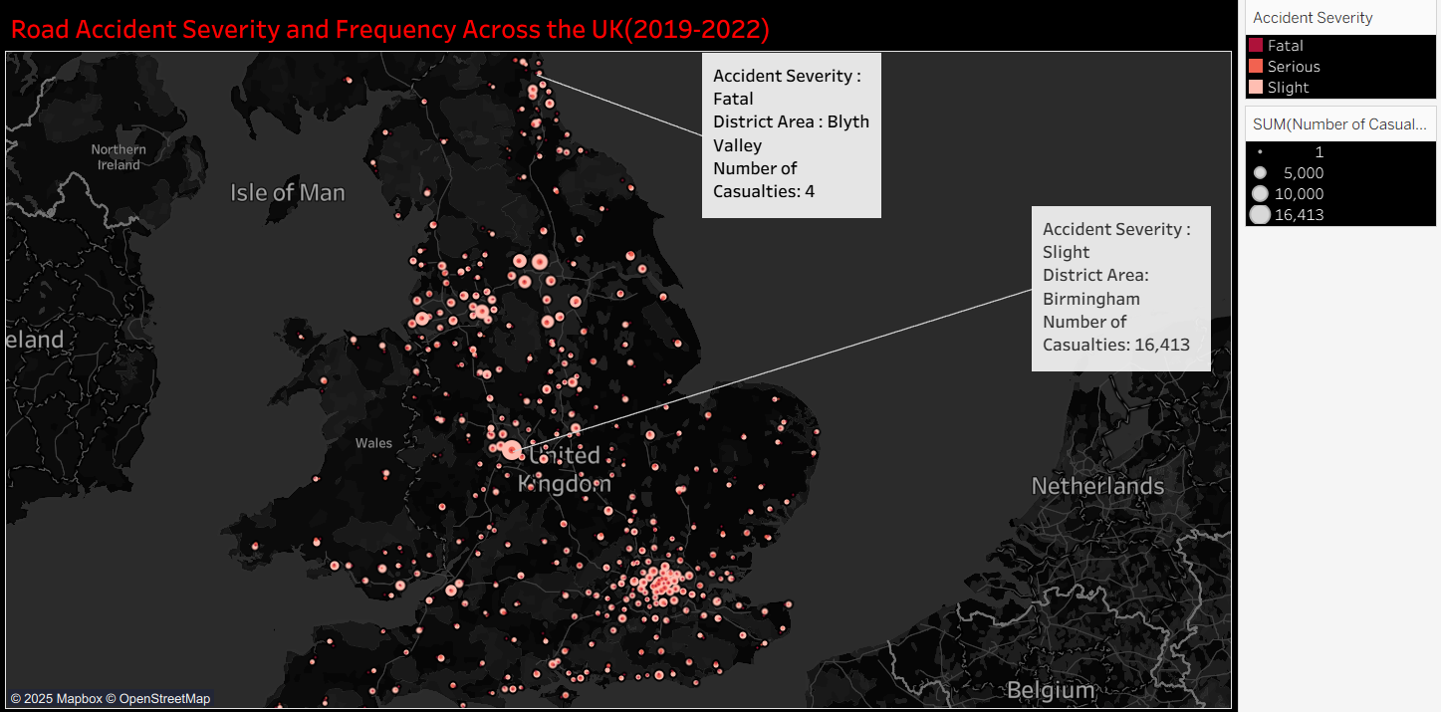
B2. Accident Severity by Vehicle Type
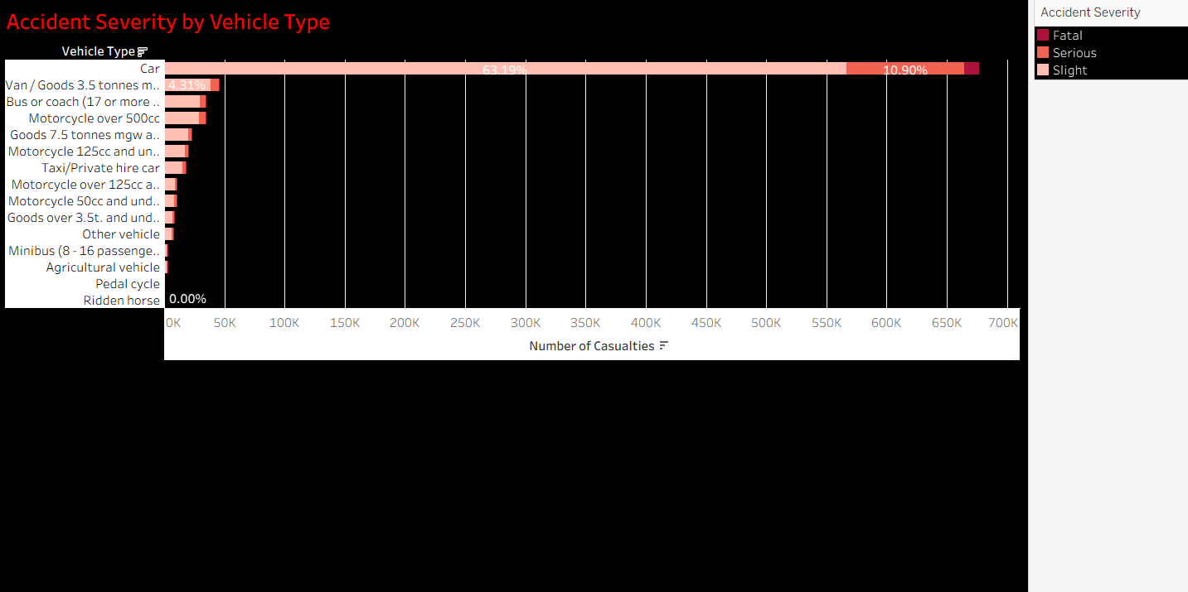
Appendix C – Data Cleaning Process
- Removed duplicate records.
- Removed entries with missing geospatial coordinates for mapping purposes.
Appendix D – Contribution Log
